EVENT BASED PROGRAMMING

What is an Event?
Change in the state of an object is known as event i.e. event describes the change in state of source. Events are generated as result of user interaction with the graphical user interface components. For example, clicking on a button, moving the mouse, entering a character through keyboard,selecting an item from list, scrolling the page are the activities that causes an event to happen.

Types of Event
The events can be broadly classified into two categories:
- Foreground Events - Those events which require the direct interaction of user.They are generated as consequences of a person interacting with the graphical components in Graphical User Interface. For example, clicking on a button, moving the mouse, entering a character through keyboard,selecting an item from list, scrolling the page etc.
- Background Events - Those events that require the interaction of end user are known as background events. Operating system interrupts, hardware or software failure, timer expires, an operation completion are the example of background events.

What is Event Handling?
Event Handling is the mechanism that controls the event and decides what should happen if an event occurs. This mechanism have the code which is known as event handler that is executed when an event occurs. Java Uses the Delegation Event Model to handle the events. This model defines the standard mechanism to generate and handle the events.Let's have a brief introduction to this model.
The Delegation Event Model has the following key participants namely:
- Source - The source is an object on which event occurs. Source is responsible for providing information of the occurred event to it's handler. Java provide as with classes for source object.
- Listener - It is also known as event handler.Listener is responsible for generating response to an event. From java implementation point of view the listener is also an object. Listener waits until it receives an event. Once the event is received , the listener process the event an then returns.
The benefit of this approach is that the user interface logic is completely separated from the logic that generates the event. The user interface element is able to delegate the processing of an event to the separate piece of code. In this model ,Listener needs to be registered with the source object so that the listener can receive the event notification. This is an efficient way of handling the event because the event notifications are sent only to those listener that want to receive them.

Steps involved in event handling
- The User clicks the button and the event is generated.
- Now the object of concerned event class is created automatically and information about the source and the event get populated with in same object.
- Event object is forwarded to the method of registered listener class.
- the method is now get executed and returns.

Points to remember about listener
- In order to design a listener class we have to develop some listener interfaces.These Listener interfaces forecast some public abstract callback methods which must be implemented by the listener class.
- If you do not implement the any if the predefined interfaces then your class can not act as a listener class for a source object.

Callback Methods
These are the methods that are provided by API provider and are defined by the application programmer and invoked by the application developer. Here the callback methods represents an event method. In response to an event java jre will fire callback method. All such callback methods are provided in listener interfaces.
If a component wants some listener will listen to it's events the the source must register itself to the listener.

Lab Task:
A university is developing a Student Registration Form where students will enter:
- personal information
- academic details
- preferences
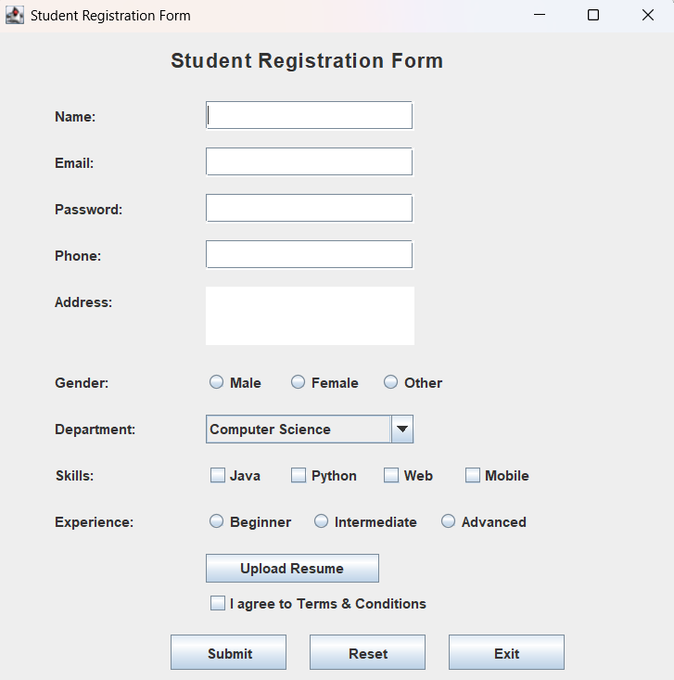
Use the same frontend GUI from previous lab and implement:
- Backend functionality
- Event handling
- Exception handling using try-catch-finally

Requirements

Submit Button
Validate all fields and display data using JOptionPane.

Reset Button
Clear all fields, radio buttons, and checkboxes.

Exit Button
When the user clicks the Exit button:
- Display confirmation message:
"Are you sure you want to exit?"
- If the user selects Yes, close the application.

Required Validations

Field | Validation | Exception Handling
Name | Cannot be empty, only alphabets | Exception for empty/invalid input
Email | Must contain @ and .com | Exception for invalid email format
Password | Minimum 8 characters | Exception for weak password
Phone | Only digits, length = 11 | NumberFormatException / Exception
Address | Cannot be empty | Exception for empty field
Gender | One option must be selected | Exception if not selected
Department | Department must be selected | Exception for default selection
Skills | At least one skill required | Exception if none selected
Terms & Conditions | Must be checked | Exception if unchecked

